Chapter 7 Fractals Through a Chaos game :
Power of iteration and iterative thinking
7.1 Introduction
Chaos game is a simple mathematical experiment which opens up a door to the concept of fractals and chaos theory. These are two very interesting and widely researched areas in mathematics. Applications are abundant and can found in every branches of Science. Dicussion of this left to a later chapter. Let us focus on this simple game and implement in Excel. The result will be surprising.
To play the game, we start with three points that outline a triangle.
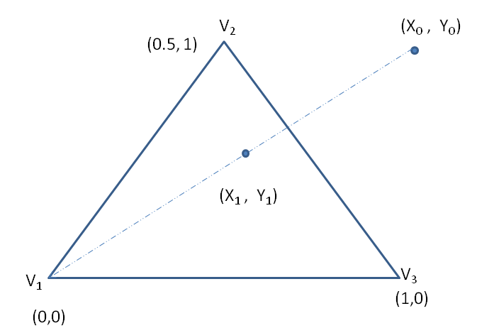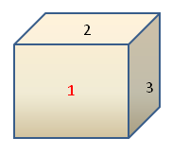
Figure 7.1 Start of Chaos game
We denote the vertices of triangle as V₁, V₂, V₃ and respective coordinates be (0,0) ,(0.5,1) and (1,0) . This is the playing board for the game. We also have a die whose two faces are marked as 1, another two faces with 2 and third pair with 3. Now we pick a point at random. This point can be within the triangle outline , or outside of it. Roll the die. If the outcome is 1, we move halfway towards vertex V₁ and plot a point. Similarly, if the outcome is 2 we will move halfway towards vertex V₂ and plot a point. Else we move halfway towards V₃ and plot a point.
Once we plot a point, we again throw the die and decide where to move and plot. Suppose we repeat this process 10,000 times and erase the first few points (this number is arbitrary, we may take it as 50) the figure look like the one given below.
This is famous Sierpinsky triangle.
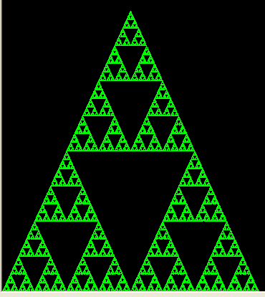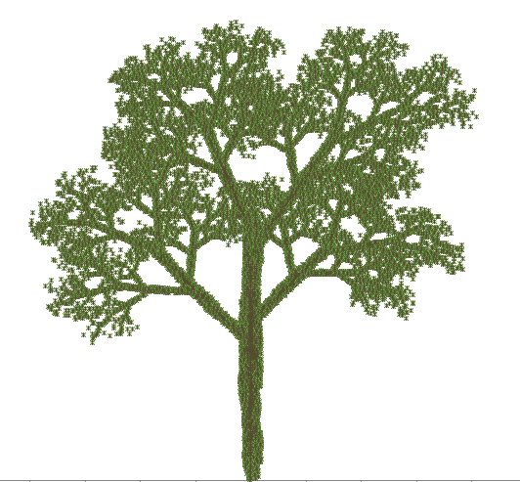
Sierpinsky triangle IFS Tree
Figure 7.2 Sierpinski triangle and a fractal tree
There are a variety of pictures which can be drawn by this principle. Since these are drawn through an iterative process, we call the set of rules used to create such pictures as “Iterative Function Systems’. See figure 7.3 below

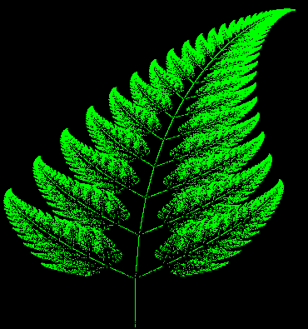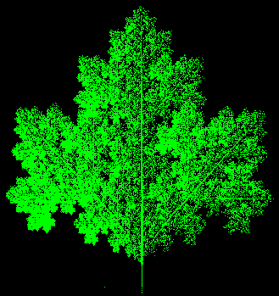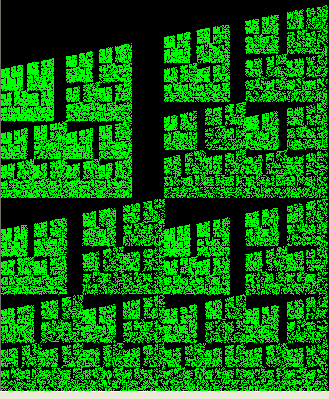
Fern Leaf Maple Leaf Castle Wall
Figure 7.3 Figures that are generated by iterative process like chaos game
Iterative process pervades everywhere - in nature as well as in man-made social and economic systems. Almost all natural processes are iterative in nature. It does not mean that it is a deterministic process. Randomness is built into it. Weather is a typical example. Long term and precise prediction of weather is impossible. Natural events and scenes are result of an ongoing iterative process. Thus study of iterative processes and their properties are of paramount importance for human kind.

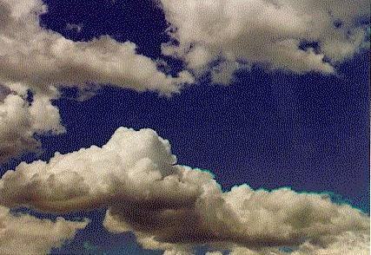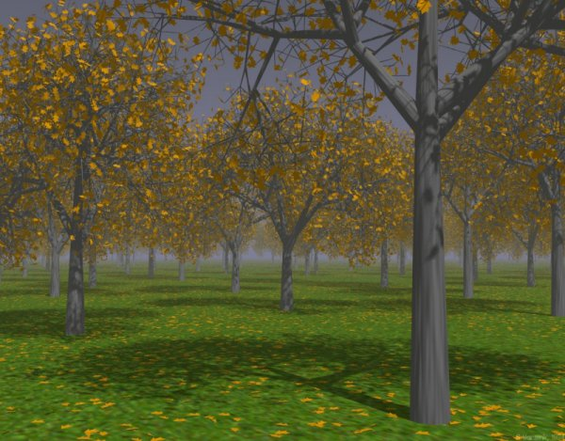

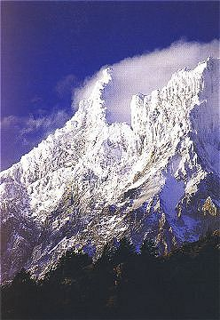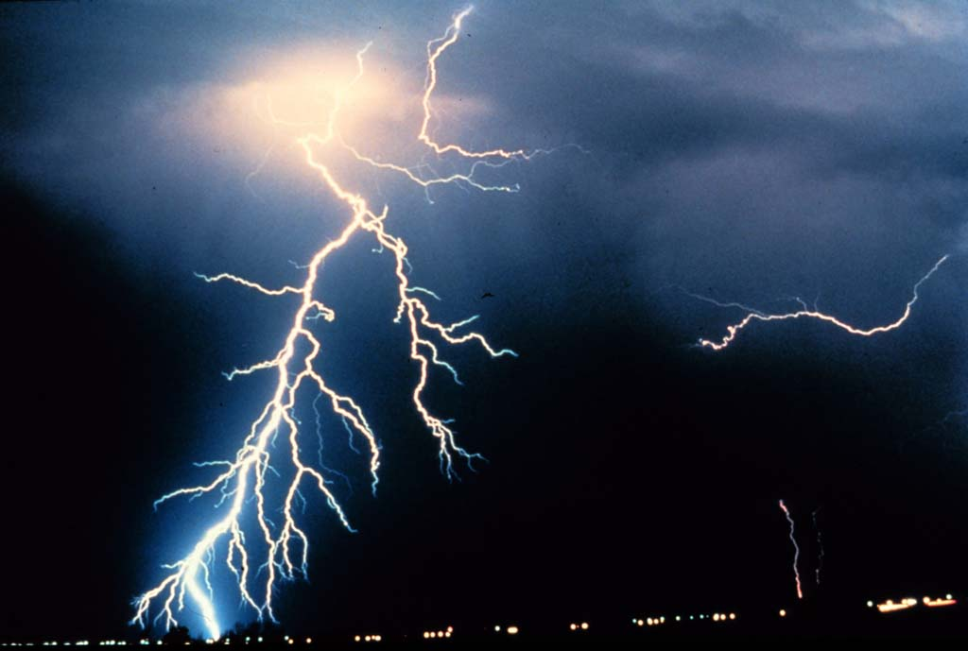
Figure 7.4 Natural images that are the result of iterative process occuring in nature

All the above natural scenes are result of some iterative process.
Sierpinsky Triangle can be produced through another iterative process. First consider a solid plane triangle. Join the midpoints of each side and cut out the middle portion. Do the process on the resulting three solid triangles. Repeat the process for ever. Figure below shows a few stages of the iteration and the output of each of those iterations.
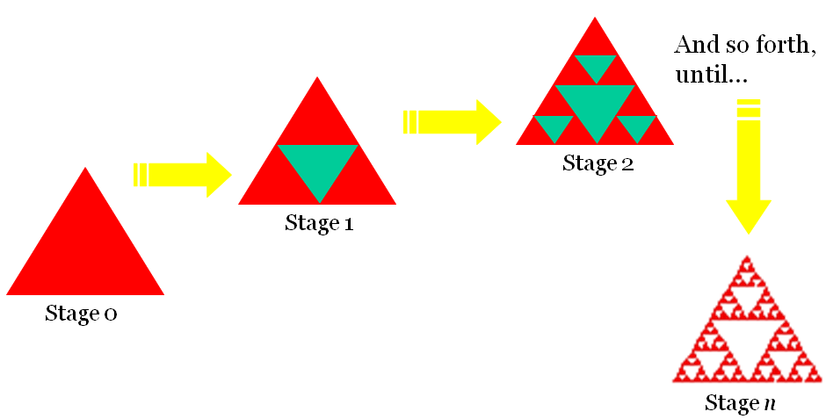
Figure 7.5 Sierpinsky triangle by another iterative process (second method)
Note that the resulting figure is not really the usual triangle. Let us study its properties.
The first striking feature is that it is self-similar.
A figure is self-similar if a part of the figure contains on a smaller scale an exact copy of the figure itself. If we were to choose a portion of the figure, and blow it up to the same size as the figure, you would see an exact copy.

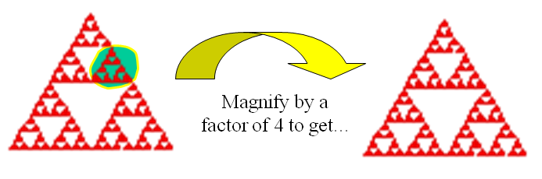
Figure 7.6 Sierpinsky Triangle is self-similar.
Second property is that its perimeter is infinite. Figure below shows that as the iteration number increases, its perimeter increases geometrically.
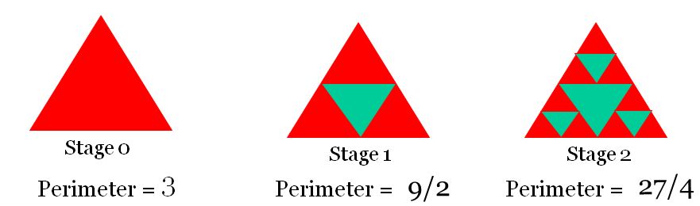
Figure 7.7 Sierpinski Triangle has infinite perimeter
Third property is that enclosed area is zero. Every iteration removes some area from the triangle. Finally the figure is a set of points without having any area enclosed.
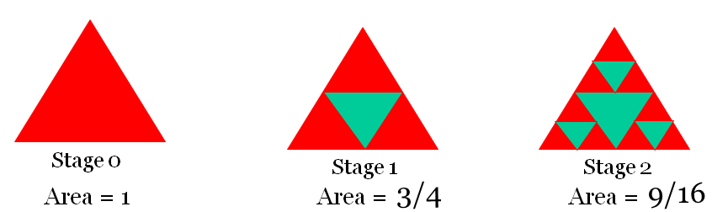
Figure 7.8 Area enclosed by Sierpinski Triangle is zero
There is still one more iterative way of creating Sierpinsky triangle. We start with a line segment and the iterating rule is to replace the line segment with a shape
Like this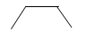. It can be placed inward or outward. In every iteration we replace consecutive segments inward and outward direction alternately. Also if in one iteration, we started replacing first (leftmost) segment in inward direction, in the next iteration we will start replacing in outward direction. See the figure below for more clarity.
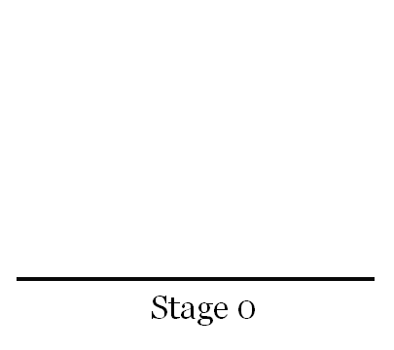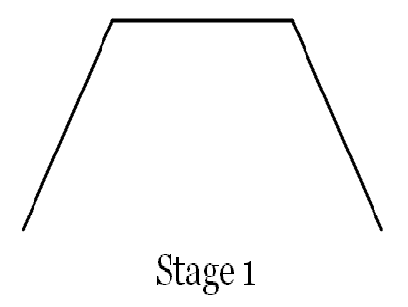

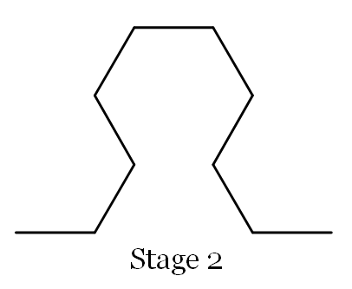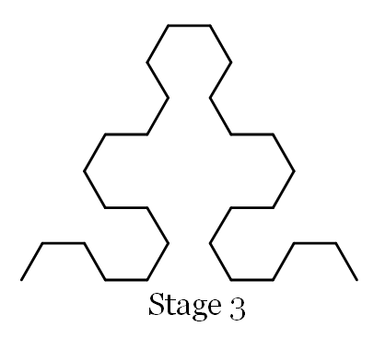

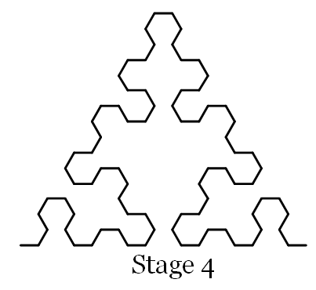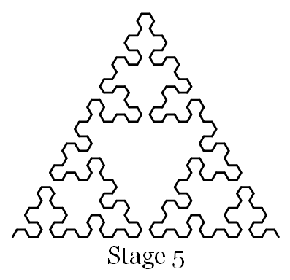

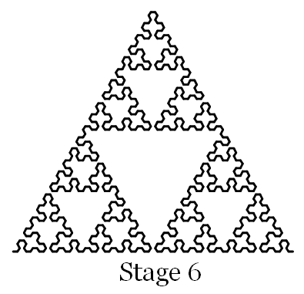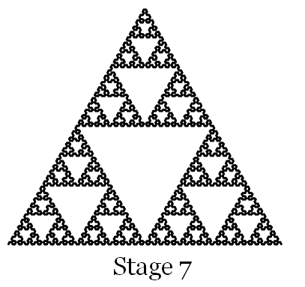
Figure 7.9 Sierpinski triangle by a third type of iterative process
7.2 Chaos Game Experiment in Excel.
Let us first map the problem into excel. Throwing of die can be mapped into excel by the use of rand ( ) function. We want integers 1, 2, 3 to happen randomly. This is achieved by = int (rand ()*3) +1. We will generate these numbers in a column and number in each cell represent outcome of the throw of die. The initial x and y coordinates of the starting point can also be generated randomly using rand ( ) function. We generate these in two separate cells. The next step is to find subsequent x, y coordinates. The required updating rule is found out as follows.

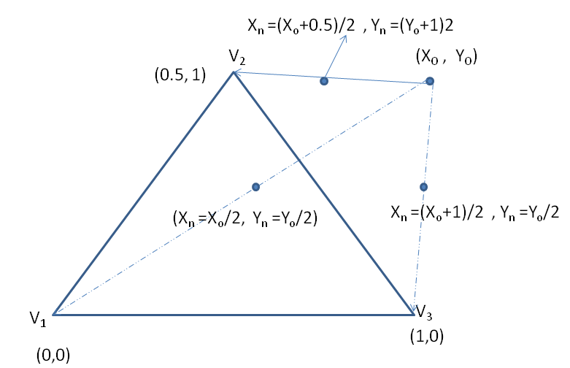
Figure 7.10 Mathematical modelling of chaos game
If random number is 1, the point moves halfway towards vertex V₁. Since coordinate of V₁ is (0, 0), the coordinate of the centre point is obtained as
X_{new} = X_{old} /2, and Y_{new} = Y_{old}/2 .
If random number is 2, the point moves halfway towards vertex V₂. Since coordinate of V₂ is (0.5, 1), the coordinate of the centre point is obtained as
X_{new} = ( X_{old} +0.5)/2, and Y_{new} = (Y_{old}+1)/2 .

If random number is 3, the point moves halfway towards vertex V₃. Since coordinate of V₂ is (1, 0), the coordinate of the centre point is obtained as
X_{new} = ( X_{old} +1)/2, and Y_{new} = Y_{old}/2 .
Implementation of this logic requires the help of ‘IF’ function in excel. Excel provides nested ‘IF’ function.
To find new x-coordinate based on random integer generated, our logic in pseudo code is
If (rand_no_generated is 1) then X_{new} = X_{old} /2
Else if ( rand_no_generated is 2) then X_{new} = ( X_{old} +0.5)/2
Else X_{new} = ( X_{old} +1)/2
Endif
Let us see how this is implemented in excel assuming cell A2 contains integer random number and cell B1 contain old x-value (previous point’s x-value). In cell B2 we are going to find new x-coordinate based on random number in cell A2. The formula to be written in cell B2 is
= if(A2=1, B1/2, if(A2=2, (B1+0.5)/2, (B1+1)/2))
This reads as
If (A2=1) , content of cell B2 is B1/2
Else if (A2=2) , content of cell B2 is (B1+0.5)/2
Else content of cell B2 is (B1+1)/2
Endif
Similarly we can find update formula for y-coordinates.
Cell updating Strategy in picture

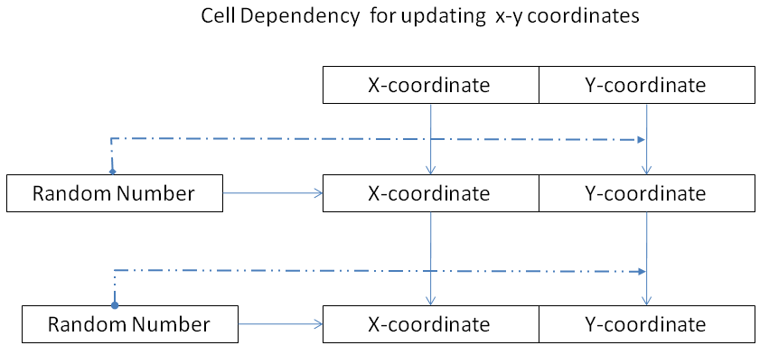
Figure 7.11 Spreadsheet implementation model of chaos game

7.3 Contractive mapping and Sierpinsky Triangle
The three updating rules in matrix form can be written as follows
Rule 1
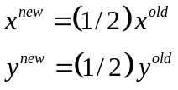
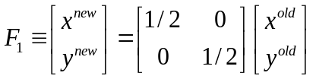
Rule 2
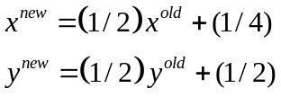
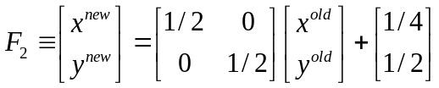
Rule 3
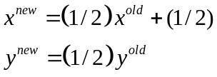
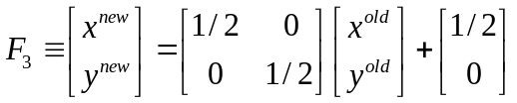
These three rules 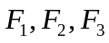 are now onwards viewed as mapping ( a function which maps one vector to another vector) since every rule maps point 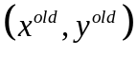 to 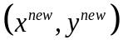.
We are now going to link the game with mathematics of contractive mapping.
Consider all the points inside Triangle ABC. Of course there are infinite points inside any triangle. Don’t bother. Let us try to find where this point is mapped if we apply the first transformation (Rule 1). We need not try all the points inside triangle. We try it on the co-ordinates of vertices A, B, C
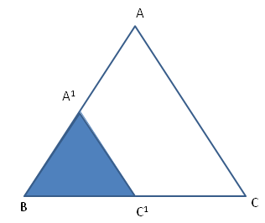
Figure 7.12 Result of applying rule-1

It is easy to see that A maps to A¹ B Maps B itself and C maps to C¹.
That is F₁ maps triangle ABC to Triangle A¹BC¹ .
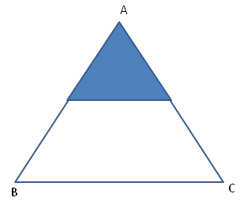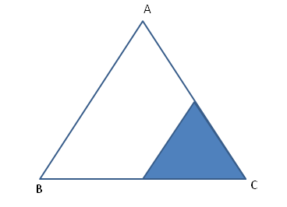
Figure 7.13 Result of applying rule-2 and Rule-3

Similarly F2 and F3 maps triangle ABC to triangles shown in dark in the figures shown above. The union of these three triangular region shown in figure below.

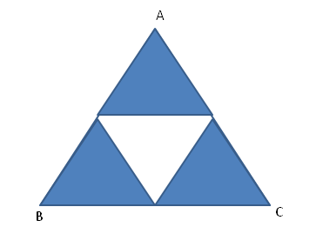
Figure 7.14 Union of the Result of applying rule-1, rule-2 and rule-3

Mathematically 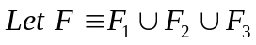
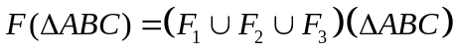
Imagine what happens if F applied again on the figure we obtained . A little consideration will show that , it will result in
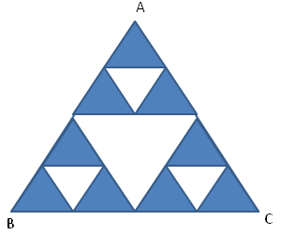
Figure 7.15 Union of the result of applying the three rules on domain represented by Figure 7.14
Mathematically above figure is 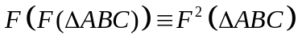
Suppose we repeat this process forever, that 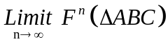 converges to a set of points called Sierpinsky triangle. On these set, if we apply again F , we will get the same figure.
Note that each mapping is a contracting mapping since when we applied on a triangle , we obtained a smaller version of the same triangle. When we apply these set of mapping infinite number of time, we find that it converges on a set of points. These set of points are called ‘Strange attractors’. It is popularly known as Iterated Function System Fractal or IFS Fractal.
The reason is this. We started with a triangle and we finally obtained a Sierpinsky triangle. But a theorem called “Collage” theorem says that even if we start from any figure (shape) in the plane, finally it ends up in the same Sierpinsky triangle. It is as if there is a strange set of points lurking in the space corresponding to the given set of contractive mapping rules. More interestingly, we can start with any point in the plane and apply the individual rules randomly , we again end up in moving along the strange attractor. That is, after applying the rule randomly, at certain iteration, the points fall on one of the points on the attractor and there onwards it will be moving along the strange attractor (Sierpinsky triangle) only.
That is the reason for the chaos game always produces Sierpinsky triangle.
In general we describe general contractive mapping as
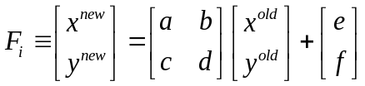
Thus each mapping consists of 6 numbers a,b,c,d,e,f
These numbers will be tabulated and given in a table. For example, for Sierpinsky triangle, all transformation are prescribed as a table as shown in Table 7.1. We call it as IFS mapping table( Iterative function system mappping table)
Table 7.1 IFS table
 | a | b | c | d | e | f | p
F1 | 0.5 | 0 | 0 | 0.5 | 0 | 0 | 1/3
F2 | 0.5 | 0 | 0 | 0.5 | 0.25 | 0.5 | 1/3
F3 | 0.5 | 0 | 0 | 0.5 | 0.5 | 0 | 1/3

The last column contains probability. This prescribes with what probability we should apply the rules. Even if we change the probability, it will not affect the final result. It only affects the speed with which we cover different parts of the strange attractor. We have a separate chapter for IFS implementations in Excel.
Experiment No: 1 Generation of Serpenski Triangle in excel
Step1: Generate the random toss 1 , 2 or 3 by entering the formula =INT(RAND()*3+1) in cell A2 and pull down to cell A5000.
Step2: Generate 2 random numbers by the entering the formula =RAND() in cell B2 and C2.
Step3: Enter the formula =IF(A3=1,B2/2,IF(A3=2,(B2+1)/2,(B2+0.5 )/2) in cell B3 and pull down till cell B5000.
Step4: Enter the formula =IF(A3=1,C2/2,IF(A3=2,C2/2,(C2+0.5 )/2) in cell C3 and pull down till cell C5000.
Step5: Now select cells from B3:C5000 and use Insert->Chart->XY(Scatter) .You get a window as shownin Fig 7.16.
Step6: Click Next button till it reaches Finish.

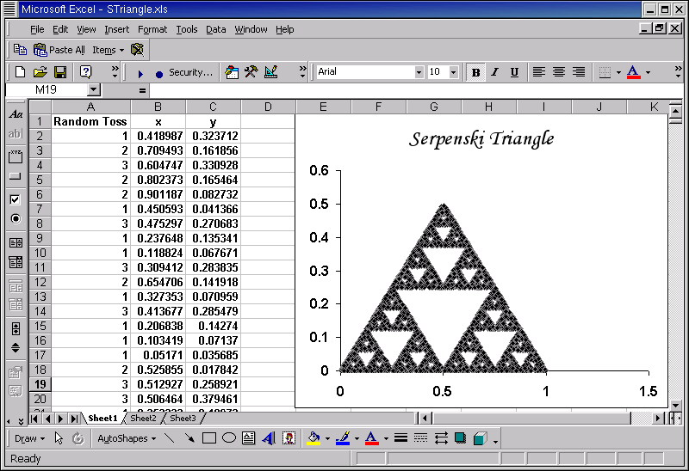
Fig 7.16 Serpenski Triangle produced in Excel

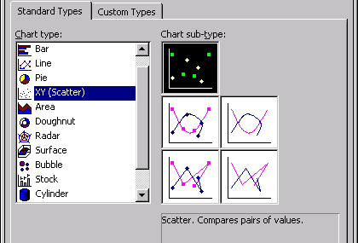
Fig 7.17 Scatter Plot to be Choosen for Drawing the Serpenski Triangle
Michael Barnsly [1] has found out a set of mapping whose strange attractor is a fern leaf. This mapping is given table 7.2 below.
Table 7.2 IFS mapping table for fern leaf
A | B | C | D | E | F | P
0 | 0 | 0 | 0.16 | 0 | 0 | 0.1
0.2 | -0.26 | 0.23 | 0.22 | 0 | 0.2 | 0.1
-0.15 | 0.28 | 0.26 | 0.24 | 0 | 0.2 | 0.2
0.85 | 0.04 | -0.04 | 0.85 | 0 | 0.2 | 0.6

An IFS fractal, according to Barnsley [1], is defined by a set of elementary geometric transformations which are called "linear" or "affine" by mathematicians. In the everyday language, they are a combination of
* translations
* rotations
* linear compressions along the vertical or horizontal axis, or both. The compression ratios along the two axes can be different.
* vertical or horizontal shears, such that a rectangle is transformed into a parallelogram through the sliding of a side along itself.
The only requirement is that the transformations must be contractive, i.e. area-reducing (at least, not increase) transformation.
All these geometric aspect of these transformation is explained in the next chapter.
Experiment No: 2 Generation of Fern leaf
Step1: Enter the probability data in cell I7:K11 as shown in the figure.
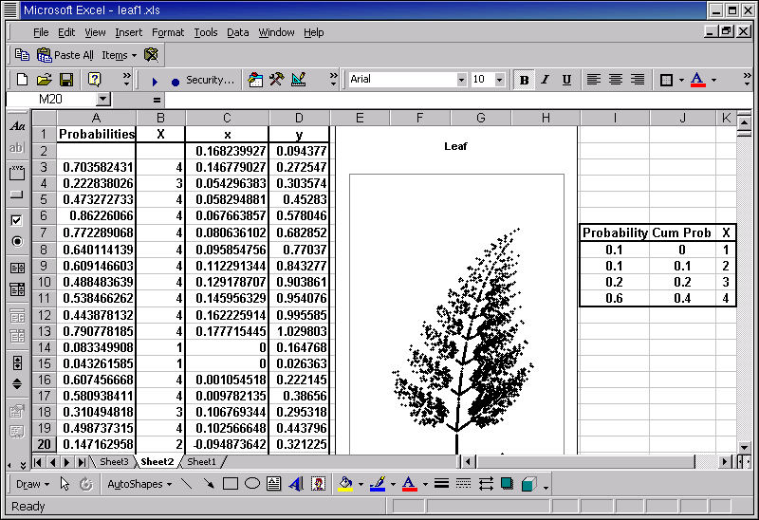
Figure 7-18 Generation of fern Leaf in Excel
Step2: Generate the probability values from cell A3:A5002 by entering the formula
=RAND() in cell A3 and pulling down till cell A5002.
Step3: Enter the formula =VLOOKUP(A3,$J$8:$K$11,2) in cell B3 an pull down till cell B5002. This generates random numbers from the set { 1,2,3,4}
Step4: In cell C2 write the formula =RAND(). (This the x coordinate of the starting point)
Step5: In cell C3 write the formula written below and pull down to cell C5002.
=IF((B3=1),0,IF((B3=2),0.2*C2-0.26*D2,IF((B3=3),-0.15*C2+ 0.28*D2,0.85*C2 + 0.04*D2)))
Step6: In cell D2 write the formula =RAND().(This the y coordinate of the starting point)
Step7: In cell D3 write the formula written below and pull down to cell D5002.
=IF((B3=1),0.16*D2,IF( (B3=2),0.23*C2 + 0.22*D2 + 0.2,IF((B3=3), 0.26*C2+ 0.24*D2 +0.2, -0.04*C2 + 0.84*D2+0.2)))
Step8: Now select cells from C2:D5002 and use Insert->Chart->XY(Scatter) to get the leaf. Now sit and enjoy the leaf you have created. Pressing Function key F9 generates a new x-y sequence but the figure mostly remain same.
One question at this stage may pop up into your mind . How are these transformation obtained?. What are its properties?.
At this stage we would like to point out only one important aspect of this transformation. ( Read the next chapter for more details.)
The transformations to be implemented in the IFS set depend upon the figure to be redrawn. There is a magical precept that must be satisfied: if the target figure is transformed through the various transformations in the set (that is through F₁, F₂,F₃ etc), one must get exact parts of this figure, and superimposing all these parts must reconstruct the whole figure. The preceding fern thus asks for 4 transformations, as illustrated below.
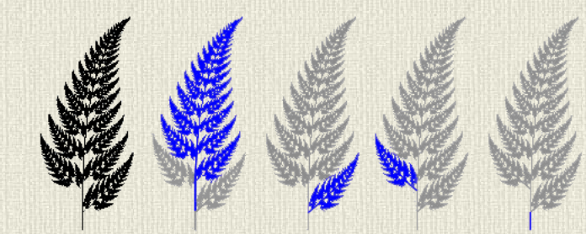
Figure 7.19 Fern leaf and its self similar parts
The result of each transformation is shown in dark. The second leaf correspond to the transformation with probability 0.6 (it has to covers maximim area and hence maximum probability is assigned) . Third and fourth leaf correspond to the transformations with probability 0.2. The last transformation is a complete compression of the fern along the piece of stem which was not covered by the three first transformations. Clearly, this splitting of the fern is based upon its strong self-similarity, which makes every leaf an exact reduction of the whole fern.
The mathematics of IFS is very interesting and you are so much interested and you are good at mathematics try reading the book ” Fractals Everywhere” by Barnsly[1]. The following pages are screen shots of the fractals you are going to create in Excel. These pictures are purposefully added for the purpose of creating the extra interest and rush to keep on reading and experimenting with Fractals. We are sure that these pictures will fulfill their assigned tasks.
7.4 Summary
IFS fractals are produced by a set of linear contractive (area-reducing) mapping followed by a translation. The final invariant set of points of the transformation is called strange attractor. The most interesting property of the figure defining this set is that it is self similar. Many of the natural objects we seen in nature have this property. They maynot be strictly self similar but self similar in a statistical sense.
7.5 Problems

- Following is IFS Table for Maple leaf. Generate and plot in Excel
a | b | c | d | e | f | p
0.35173 | 0.35537 | -0.35537 | 0.35173 | 0.3545 | 0.5 | 0.2627
0.35338 | -0.3537 | 0.35373 | 0.35338 | 0.2879 | 0.1528 | 0.2946
0.5 | 0 | 0 | 0.5 | 0.25 | 0.462 | 0.1773
0.50154 | -0.0018 | 0.00157 | 0.58795 | 0.2501 | 0.1054 | 0.2091
0.00364 | 0 | 0 | 0.57832 | 0.5016 | 0.0606 | 0.0563

- IFS Table for a tree is given below. Generate and plot in Excel

a | b | c | d | e | f | p
0.05 | 0 | 0 | 0.6 | 0 | 0 | 0.1666
0.05 | 0 | 0 | -0.5 | 0 | 1 | 0.1666
0.459627 | -0.32139 | 0.385673 | 0.383022 | 0 | 0.6 | 0.1666
0.469846 | -0.15391 | 0.17101 | 0.422862 | 0 | 1.1 | 0.1666
0.433013 | 0.275 | -0.25 | 0.476314 | 0 | 1 | 0.1666
0.421324 | 0.257115 | -0.35353 | 0.306418 | 0 | 0.7 | 0.1666

- IFS Table for a “Castle wall” is given below. Generate and plot in Excel
0.5 | 0 | 0 | 0.5 | 0 | 0 | 0.25
0.5 | 0 | 0 | 0.5 | 2 | 0 | 0.25
0.4 | 0 | 0 | 0.4 | 0 | 1 | 0.25
0.5 | 0 | 0 | 0.5 | 2 | 1 | 0.25

4 Generating points for the problem Nos 1, 2, and 3. Copy the points to a new location and make its self similar portions corresponding to different transformations as in Figure 7.19

7.6 References
[1] Michael F. Barnsley, Fractals Everywhere , Morgan Kaufmann, 1993
[2] Edgar E. Peters, Chaos and Order in the Capital Markets: A New View of Cycles, Prices, and Market Volatility, Wiley , 2nd Edition 1996
[3] R. Devaney and L. Keen, eds., Chaos and Fractals: The Mathematics Behind the Computer Graphics, American Mathematical Society, Providence, RI, 1989.
[4] K. Falconer, Fractal Geometry: Mathematical Foundations and Applications, Wiley, 2003
[5] J. Gleick, Chaos: Making a New SciencePenguin publishers, 1998 (This popular book covers the origins of chaos).
[6] H. Peitgen, H. Juergens and D. Saupe, Fractals for the Classroom. Springer; 1991
[7] B. Mandelbrot, The Fractal Geometry of Nature, published by W. H. Freeman; 1983
[8] David Mumford, Caroline Series , David Wright , Indra's Pearls: The Vision of Felix Klein, Cambridge University Press, 2002
7.7 Websites
[1] http://www.bugman123.com/Fractals/index.html
[2] http://klein.math.okstate.edu/~wrightd/INDRA/

